COMP 141: Ambiguity, EBNFs and Parsers

*Instructions:* In this exercise, we are going to review EBNFs and parsers.

# Ambiguous Grammars

Consider the following grammar with terminals: number, +, ∗, (, and ).

*expr* ::= *expr* + *expr* | *expr* ∗ *expr* | (*expr*) | number

number = [0-9]+

1. As you have seen in the slides, we can disambiguate the grammar by revising it as follows

*expr* ::= *expr* + *term* | *term term* ::= *term* ∗ *factor* | *factor factor* ::= (*expr*) | number number = [0-9]+

1. Since the grammar is disambiguated, there is only one parse tree now for each expression that can be derived from the grammar. What is the unique parse tree for deriving 78 ∗ 20 + 5 ∗ 39. Let’s call this parse tree P.

1. Give the corresponding AST for P. Let’s call it A.

1. What would be the final value if you pass A to an evaluator (in an interpreter)?

To evaluate this AST:

1. Multiply **78** by **20** to get **1560**.
2. Multiply **5** by **39** to get **195**.
3. Add the results of the two multiplications together: **1560 + 195** to get **1755**.

So the final value after evaluating the AST would be **1755**.

# EBNFs

1. As discussed in the class, given the BNF grammar

*expr* ::= *expr* + *term* | *term term* ::= *term* ∗ *factor* | *factor factor* ::= (*expr*) | *number number* ::= NUMBER

## NUMBER = [0 − 9]+

we can rewrite it in EBNF as follows.

*expr* ::= *term* {+ *term*} *term* ::= *factor* {∗ *factor*} *factor* ::= (*expr*) | *number number* ::= NUMBER

## NUMBER = [0 − 9]+

Let’s call this definition of grammar *g*1.

1. What is the derivation for 78 ∗ 20 + 5 ∗ 39 using the rules in *g*1?

1. What is the corresponding parse tree?

1. What is the corresponding AST?

2. Moreover, we can rewrite the BNF grammar

*expr* ::= *term* + *expr* | *term term* ::= *factor* ∗ *term* | *factor factor* ::= (*expr*) | *number*

as the EBNF grammar:

*expr* ::= *term* [+ *expr*] *term* ::= *factor* [∗ *term*] *factor* ::= (*expr*) | *number*

Let’s call this definition of grammar *g*2.

1. What is the derivation for 78 ∗ 20 + 5 ∗ 39 using the rules in *g*2?

1. What is the corresponding parse tree?

1. What is the corresponding AST?

# Recursive-descent parser

1. Give the pseudo-code for recursive-descent parser that implements *g*1.

1. Give the pseudo-code for recursive-descent parser that implements *g*2.

# Boolean expressions

Consider the following CFG with the eight terminals: true, false, ∧, ∨, !, ==, (, and ).

*expr* ::= true | false | *expr* ∧ *expr* | *expr* ∨ *expr* | !*expr* | *expr*== *expr* | (*expr*)

Indeed, the starting symbol is *expr*. Let’s call this grammar *G*. This grammar is ambiguous, i.e., there exist at least two parse trees for some expression. For example, in a previous lab you were able to give two different syntax trees for the following expression:

!true ∧ false ∨ true == true

1. Let’s disambiguate *G*. We want to impose the following precedence cascade among operators:
   * The highest precedence is for parentheses,
   * the second highest precedence is for !,
   * the third highest precedence is for ∧,
   * the fourth highest precedence is for ∨, and finally
   * the least precedence is for ==.

In addition, all binary operators are left-recursive. Define the disambiguated version of the grammar in BNF. Let’s call your disambiguated grammar *G*’.

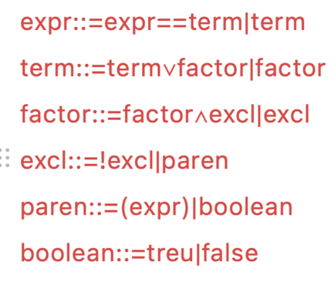

1. In your defined *G*’, is operator ∧ left-associative or right-associative? What about operator ∨?

In the defined grammar **G'**, both the **∧** (logical AND) and **∨** (logical OR) operators are left-associative.

1. Using *G*’, give the derivation for the expression below:

! true ∧ false ∨ true == true

Note that since *G*’ is disambiguated, there must be a unique parse tree for this expression.



1. Give the corresponding parse tree for the derivation in the previous question.



1. Give the corresponding AST for the parse tree in the previous question.



1. If you pass this AST to an evaluator, what would be the final result?

the final result of evaluating the AST would be **true**.

1. Redefine *G*’ using EBNF. Let’s call this version of grammar *G*’’.

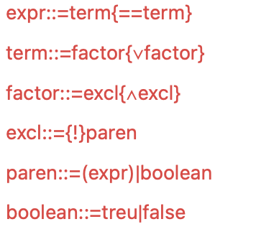

1. Give the pseudo-code for the recursive-descent parser that implements *G*’’. The parser needs to generate the AST (so it is not a recognizer!).

